16339A Component Test Fixture
Sold By: Keysight - Usually arrives in 4 weeks Visit Technical Suppor
http://www.keysight.com/en/pd-1000000506%3Aepsg%3Apro-pn-16339A/component-test-fixture?nid=-32786.536879637&cc=BY&lc=eng
Key Features & Specifications
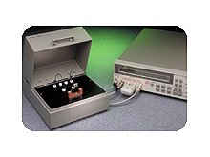

Notice for European Union Customers: This product is not updated to be EU RoHS compliant. Please contact Keysight Authorized Distributors for quotation and ordering. Keysight will continue service and support to the end of worldwide support life.

SMD Test Fixture Selection Table
Description

The 16339A is designed to operate specifically with the 4339A/B. It is provided with three component modules, which are used to hold SMD, lead and various type of devices. Electrical noise effects are reduced by the employment of a shielded case. A built-in interlocking circuit enables safe high-voltage measurements.

N1295A Test Fixture

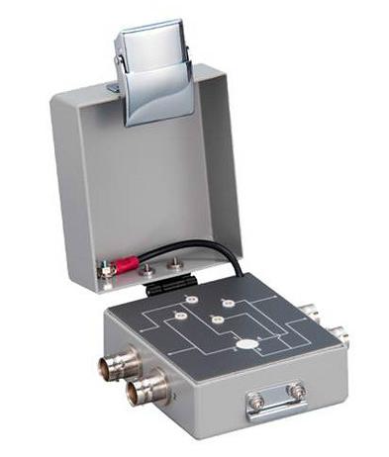

Device/Component Test Fixture for B2900A series

Four triaxial inputs

Up to 42 V/1 A measurements

The Keysight N1295A Device/Component Test Fixture provides a low-cost solution to quickly and easily test packaged devices and components. For more advanced packaged testing needs, the Keysight 16442B Test Fixture provides more capabilities.

B2900A Series Precision Source/Measure Units (SMU)
